Filter transactions for your entity in the Excel file (the tables below are presented as examples):

Open the excel file and note that the header row on the excel file is already filtered. Each column has a little downward pointing arrow.



To find your entity, locate the column labeled “Name” and click the downward arrow and a window will pop up with all the field values.

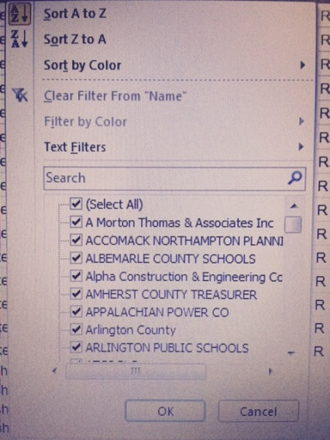

First unselect all field values by clicking on the (Select All) Button, see results below:

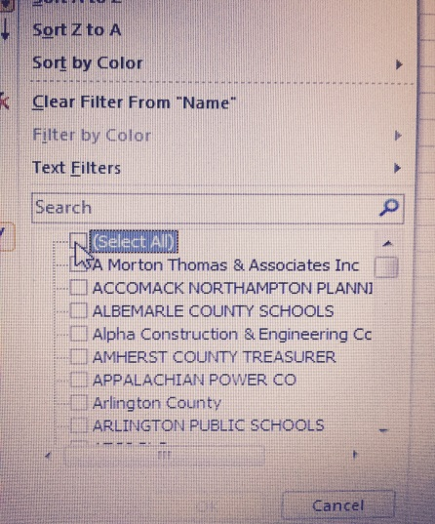

Select your entity name and then the report will filter transactions only for your entity.

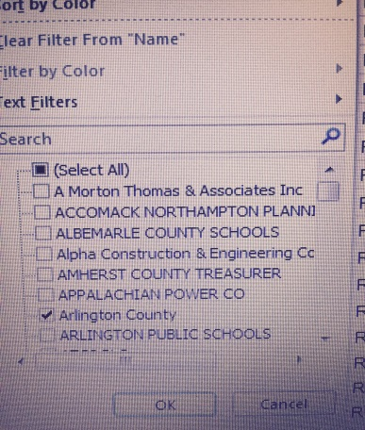

For example, if Arlington County is selected, the transaction table will appear as follows (only a subset of the data is shown here).



**Subrecipient header row terms:**

Voucher Number – Number assigned in VDOT’s accounting system to identify a record of expenditure

Fiscal Period – an interval of time during the twelve months of the Fiscal Year (1 equals the month of July, 2 equals the month of August and so forth in VDOT’s fiscal year ending 6/30/20XX)

Name – name of the sub-recipient entity

Account – classification used to record an expense transaction for accounting, financial management and budgeting purposes.

Project Number – Universal project code assigned by VDOT

Project Name- Title of project

Analysis Type - VDOT use only to determine billing status with FHWA

Rate – is the federal participation rate

Bill Date - invoice date when billed to the Federal Highway Administration

Total Expenditures - amount of total expenditure

Federal Portion of Total Expenditures – federal participation rate times the amount of total expenditure. This is the column that must be reconciled.

Sub-Recipient Invoice Date – date of the invoice from the sub-recipient entity

Invoice ID – number identifying the invoice from the sub-recipient entity

Payment Date – scheduled date of payment by VDOT to the sub-recipient entity

EDI payment reference – payment identification number

Payment Amount – amount paid to the sub-recipient entity by VDOT

(If exact payment amounts are shown in two different rows, those transactions actually pertain to the same voucher number and are on two separate rows to show the BLD amount and the OLT amount) and you need to consider this as one payment not two. The EDI payment number will be the same also. Also, note that the payment amount and total expenditure amount will not always agree because of deductions such as the sub-recipient’s responsible portion of VDOT’s expenditures on a project.